**Modules**

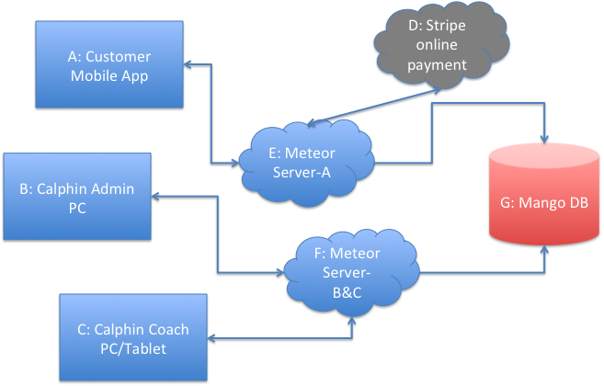

**B: Calphin Admin – PC App (C: Calphin Coach – it’s part of B, only shows coach portal)**

**Login page:**

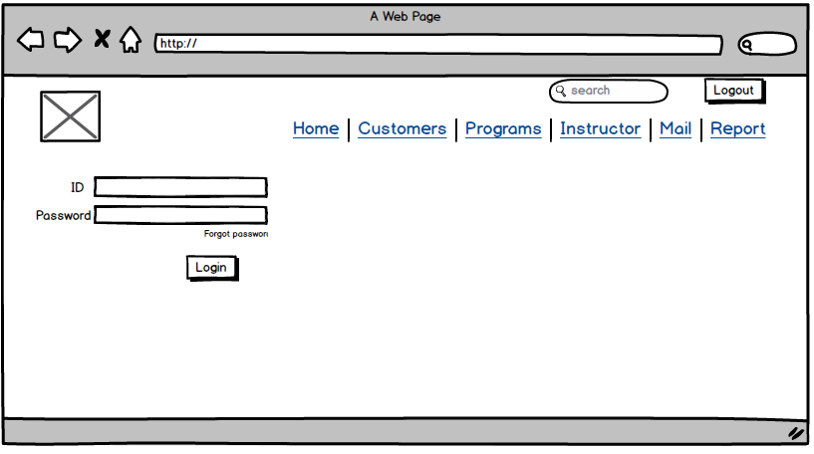

Admin user is a super user, it can overwrite all contents on this web app. Other users are “staff” – Calphin determine access

“coach” – will have access to coach portal only, Calphin determines if coach needs to see other section. System will have default login info for existing staff. Once new staff starts, admin user is responsible for setting up new account.

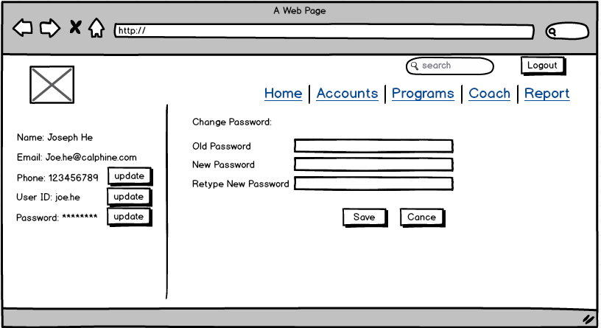

Create new staff account

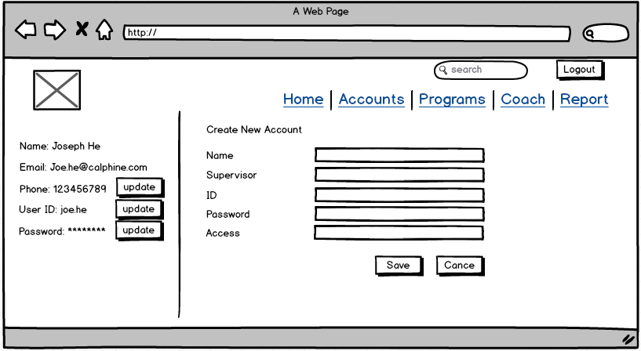

Each tab has drop down menu, click tab name, drop down menu show, click any on drop down menu, it goes to that page.

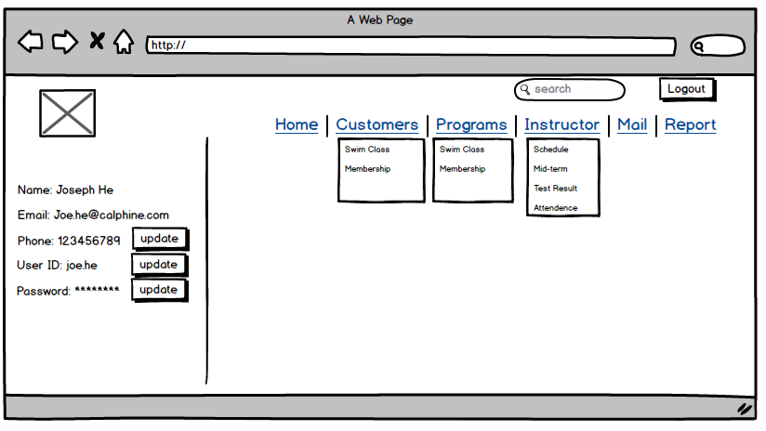

**Home page**: it could have any information Calphin wants to put there, for example, internal news, dashboard, etc

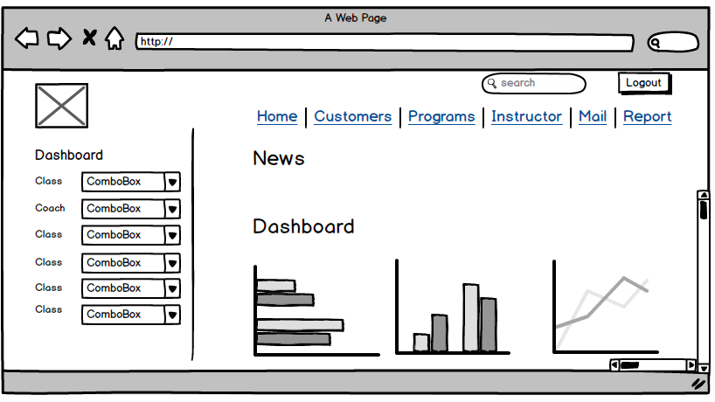

Admin users are able to edit content on homepage

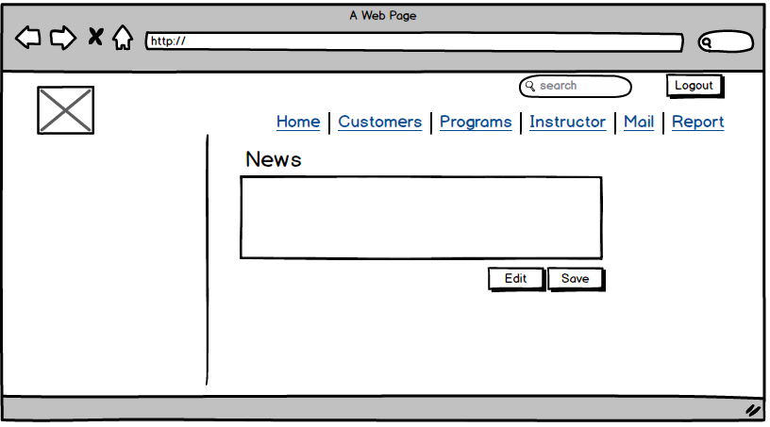

**Customers:** use ICP as reference.

Functions:

1. search customer account, search result include customer basic profile and enrollment info. Search filters are listed on the left hand.
2. If registered for class, it shows class information including billing. If enrolled for membership, it shows membership. Or both.
3. Under each swimmer, it shows swimmer name, gender ,age, enrollment history (see below)

Search account name or swimmer name, it shows below:

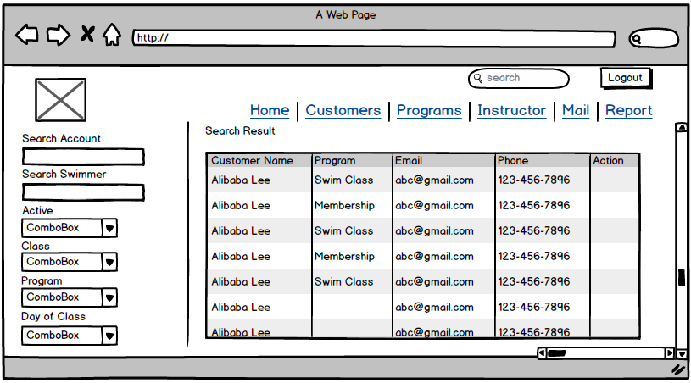

Click one customer name:

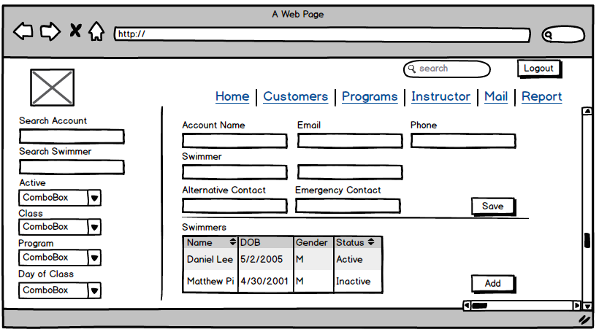

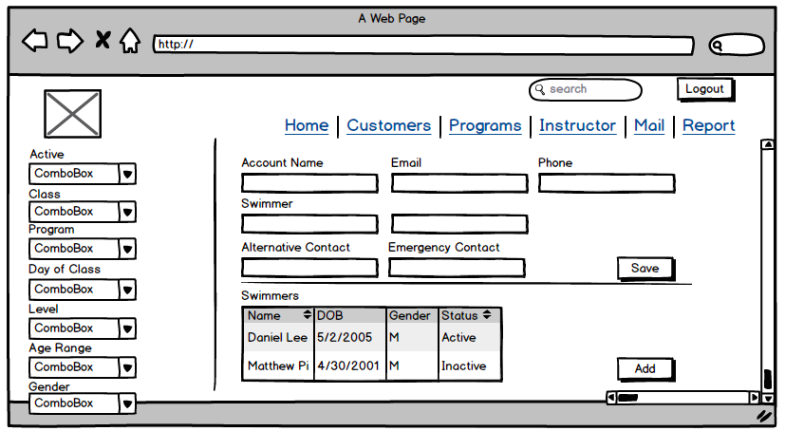

Account information is changeable for admin user and click save after each change made. All other users only have view access.

Click swimmer’s name, it shows below, class history and test result history. Account info of swimmer is listed on the left. Separated by line. There is action button for each swimmer for class registration

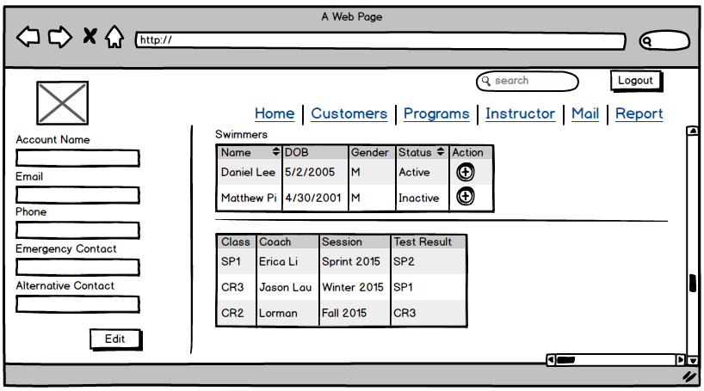

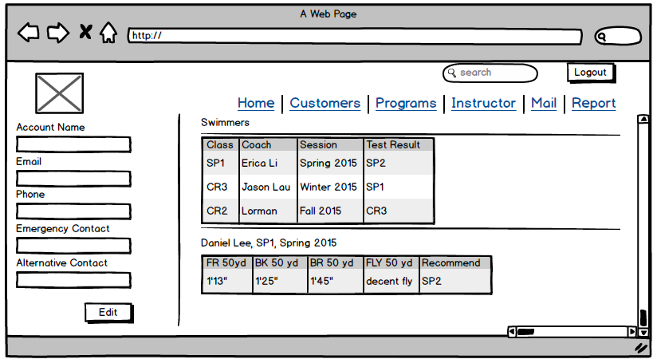

Add new swimmer (popup window)

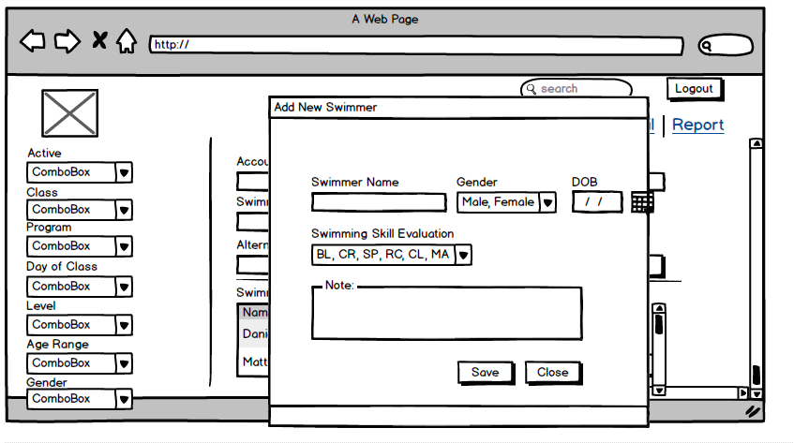

**Program**

Functions:

1. Search Function- search filters are listed on the left.

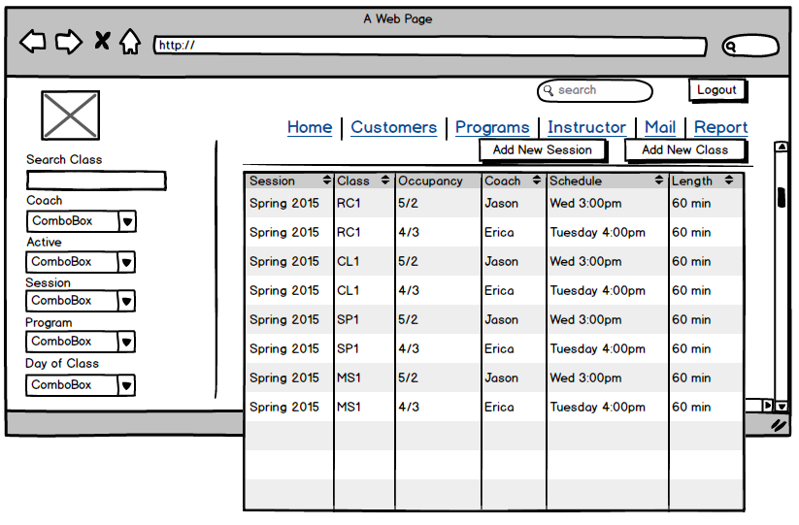

Click class name, it shows below: (class details, swimmer list, trial, makeup, waitlist info)

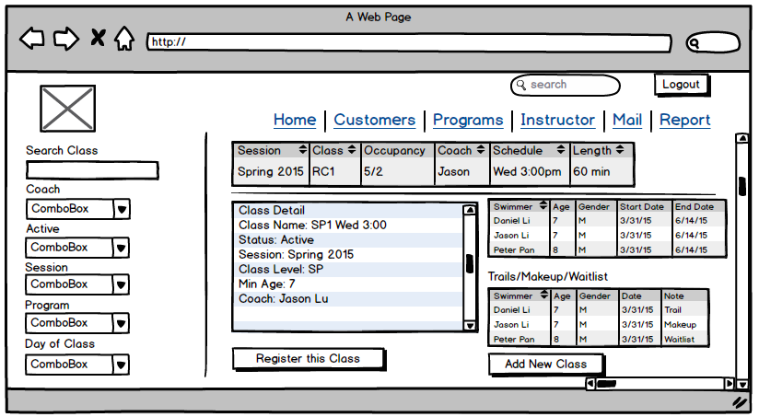

1. Add New Session, Add New Class

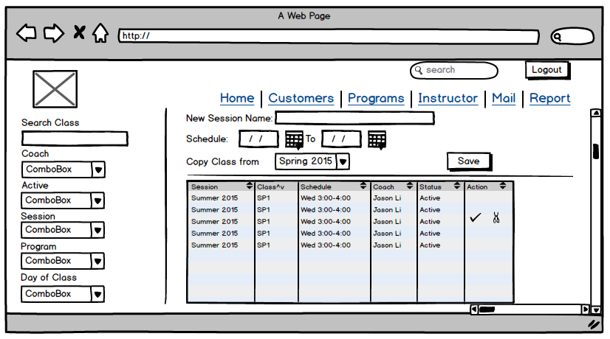

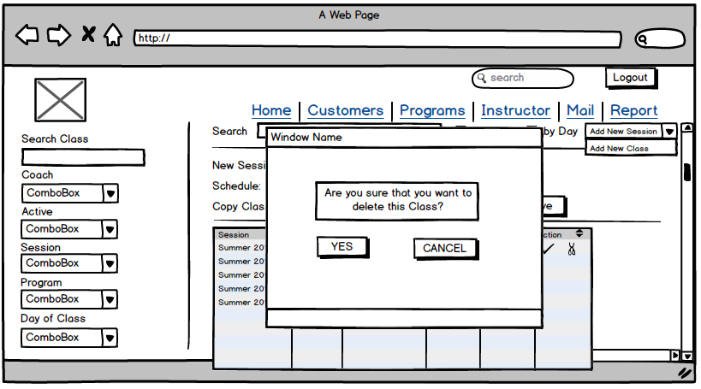

Add New Class:

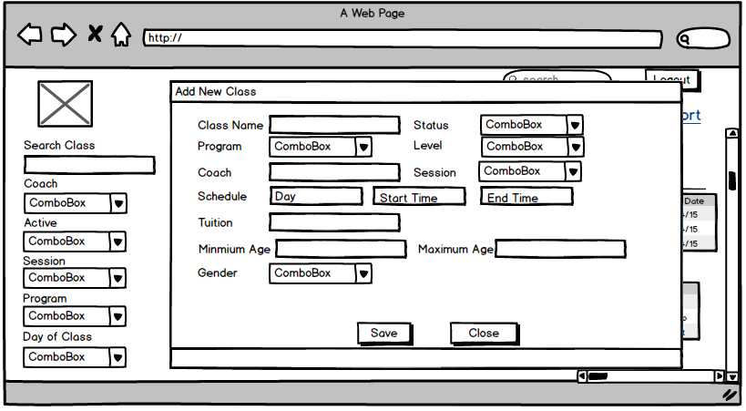

1. Register Class. Click register this class on class page

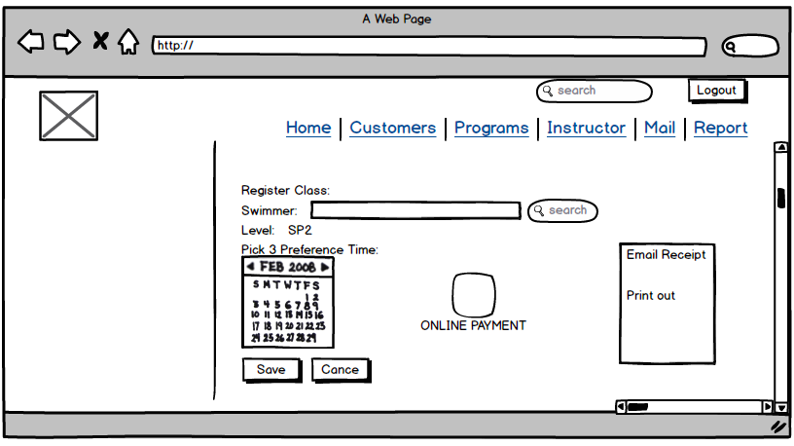

1. Enroll New Membership

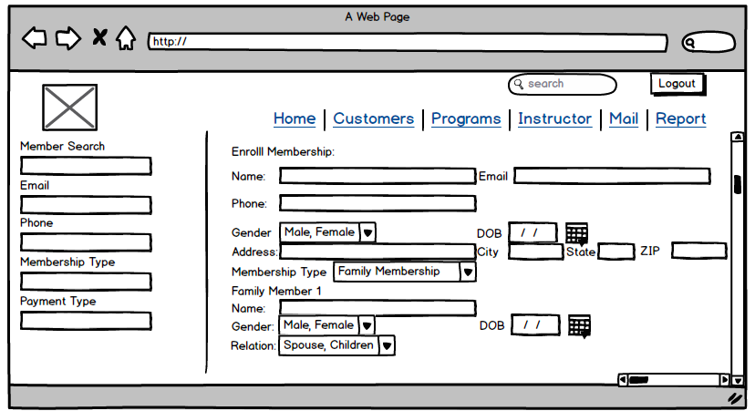

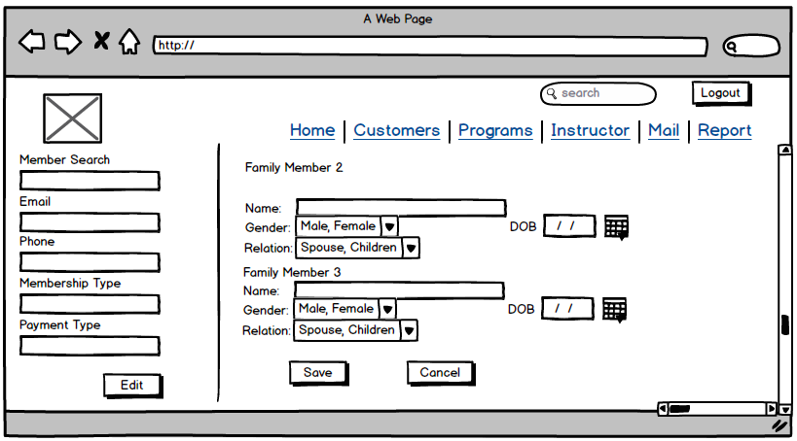

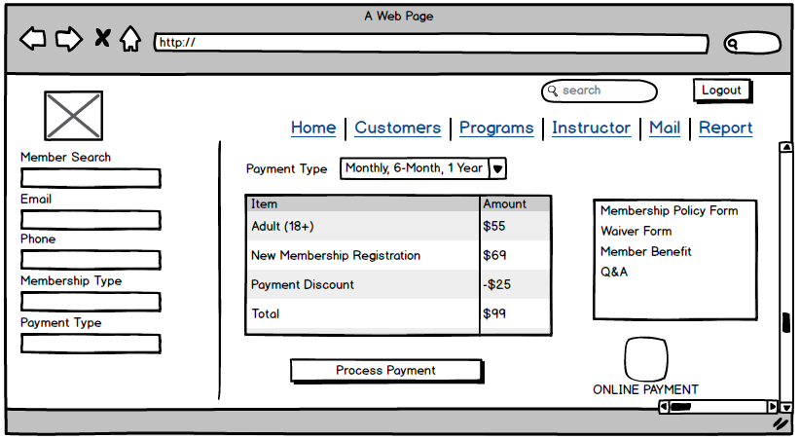

**Coach portal**: it has 4 major functions

1. Review Class Schedule – Coach is expected to check class schedule on daily basis.

Weekly calendar showing all classes this coach is teaching. Each day has a tab. Default tab is the day of viewing this schedule.

If there’s parent-coach meeting schedule, each class will have notification icon. If there’s new comment for student, each class will have notification icon.

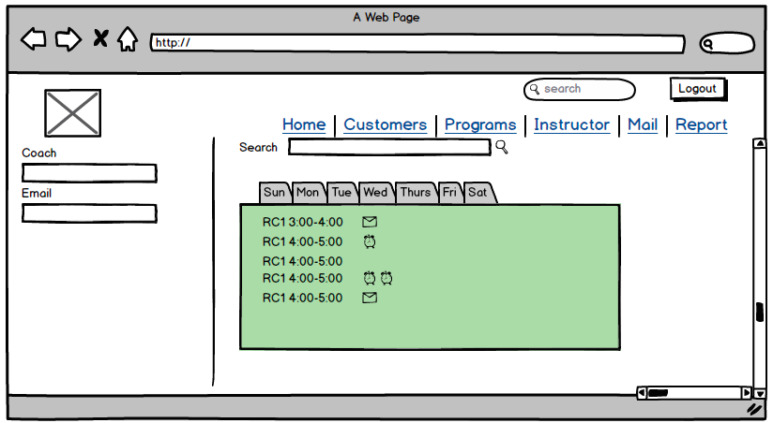

Coach clicks one class, it will show swimmer list, name, level, comments and/or parent coach meeting for that student.

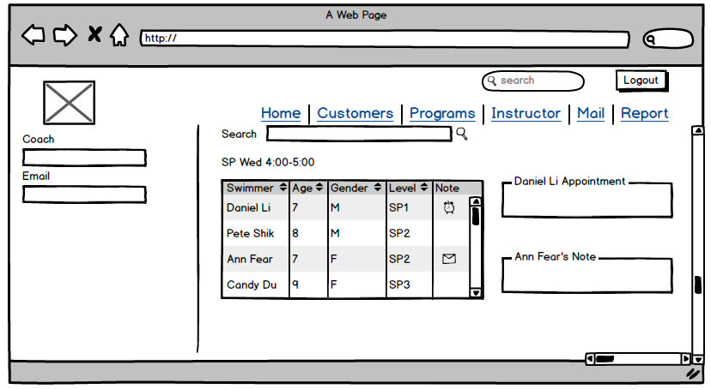

1. Input Test Result

Coach chooses class from drop down menu which shows all classes he teaches in that session. Test result recording form shown below. Each student’s result is able to send it to parents via email by mail icon.

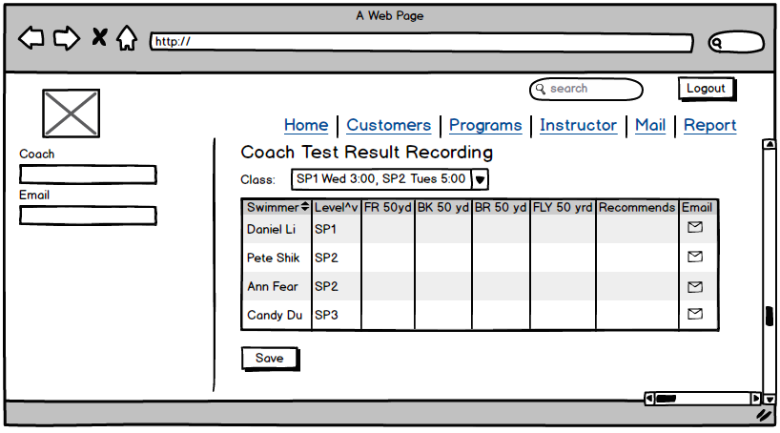

1. Mid Term Evaluation

Coach chooses class from drop down menu which shows all classes he teaches in that session. Mid term evaluation form shown below. Evaluation can be sent to parent via email by click mail icon.

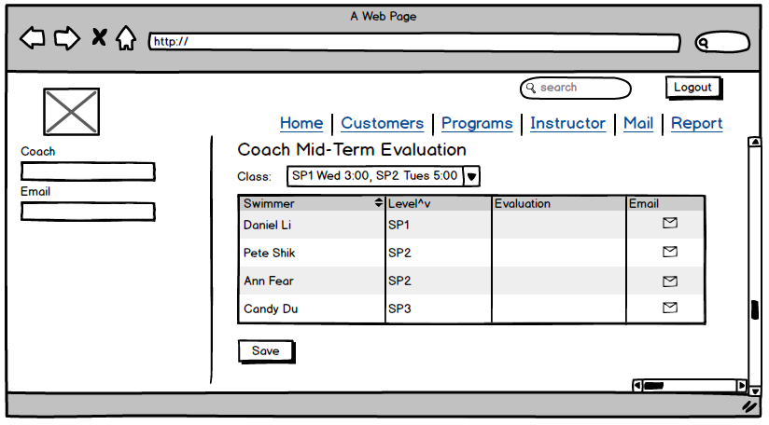

1. Coach Attendance

TBD

**Reporting:**

Search Filters determined by Calphin

Report list:

1. Master Class Schedule
2. Customer Email List